- Create one VPC, with 1 public subnet and 1 private subnet.
Step 1: Login to AWS account and click VPCCreate VPCEnter detailscreate VPC.
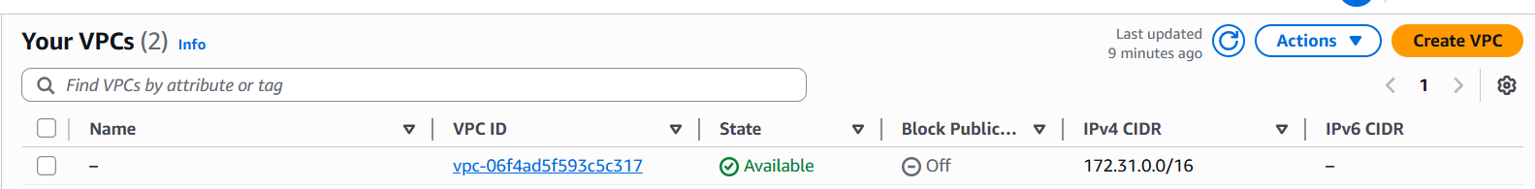
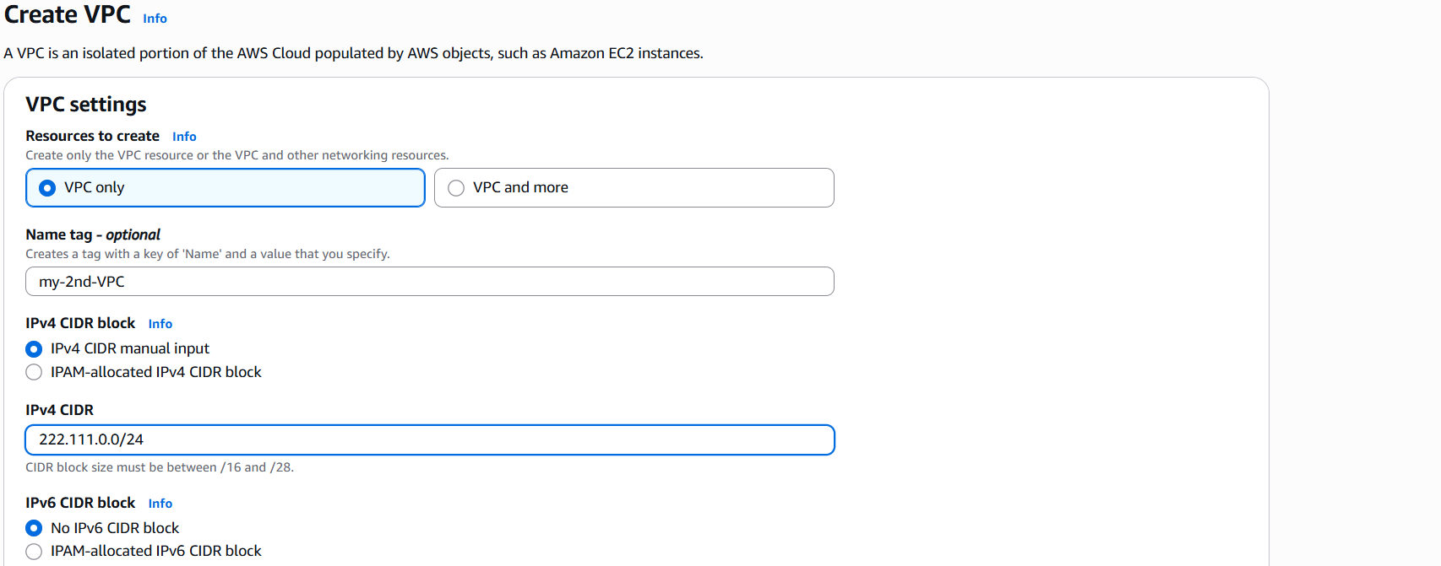
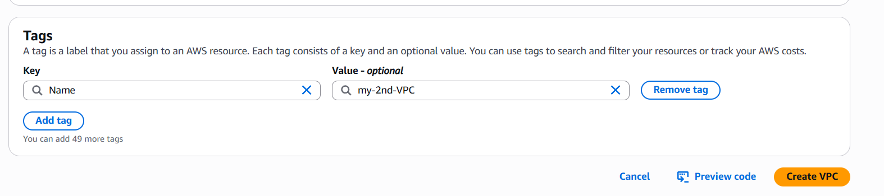
Step 2: Select Subnetscreate subnetselect your VPCEnter subnet name and CIDR range click create subnet.
Repeat the same step to create a private subnet.
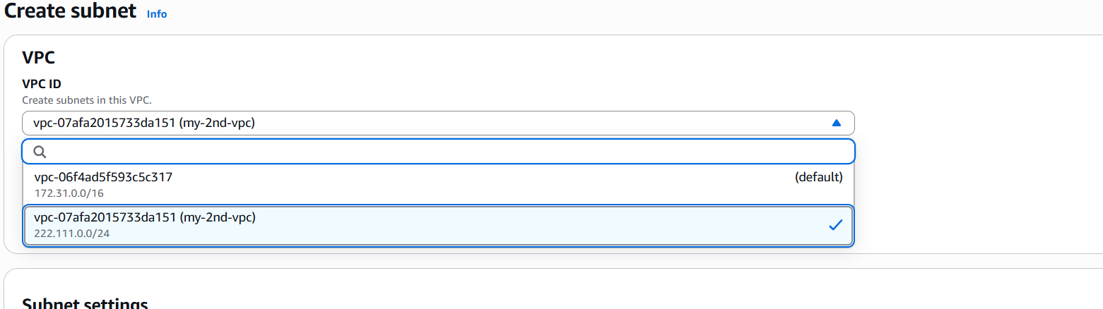
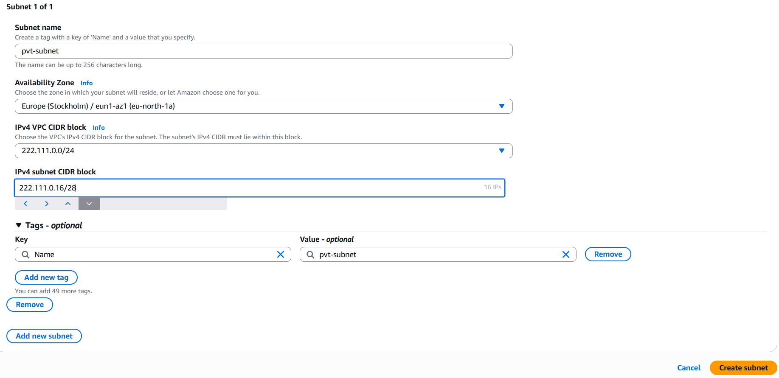
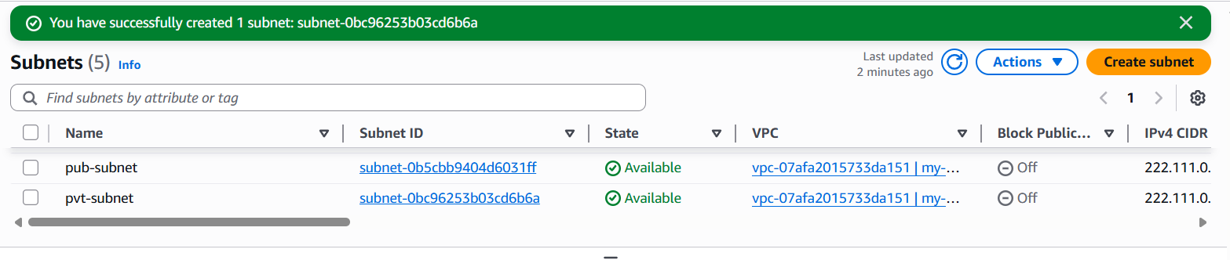
Step 3: Select Internet gatewaysCreaate IGWEnter nameCreate internet gateway.
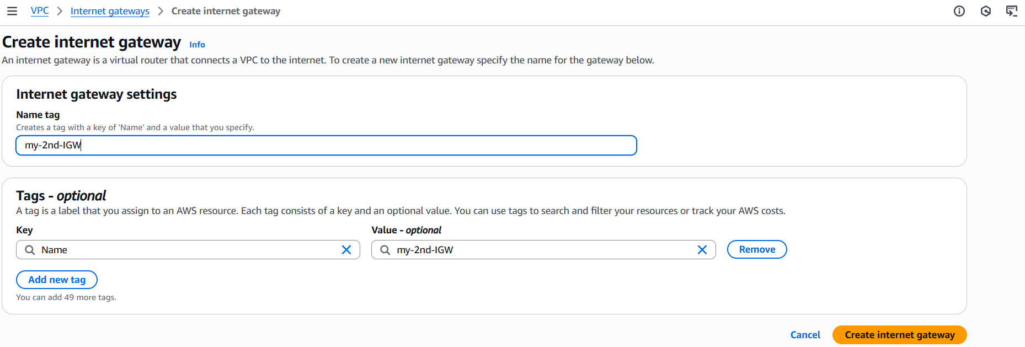
Step 4: Select ActionsAttach VPCSelect VPCAttach IGW.
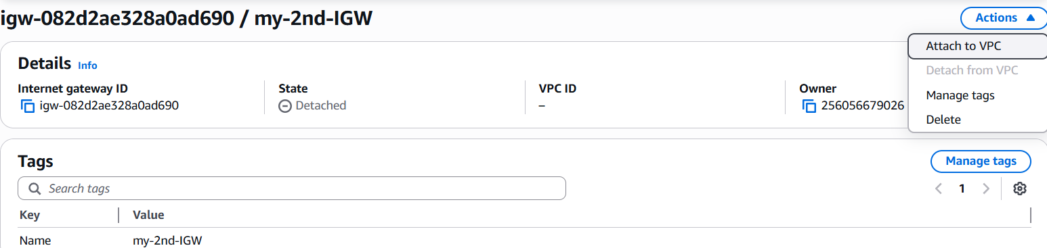
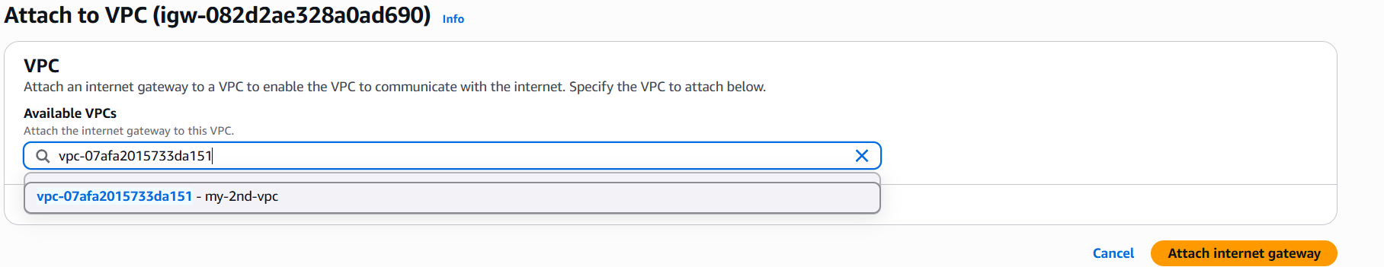
Step 5: select route tablescreate RTEnter name and VPCCreate RT.
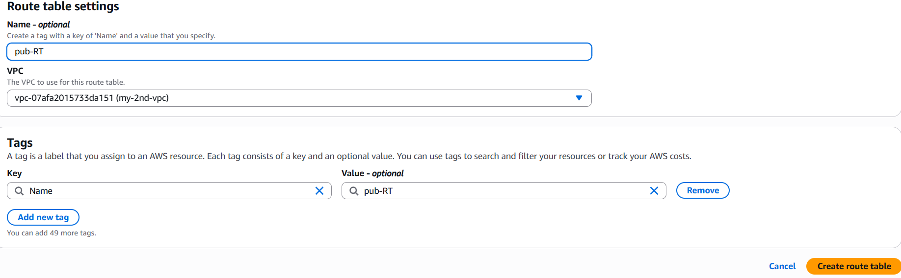
Step 6: Select RTSubnet AssociationEdit SAselect subnetsave Association.
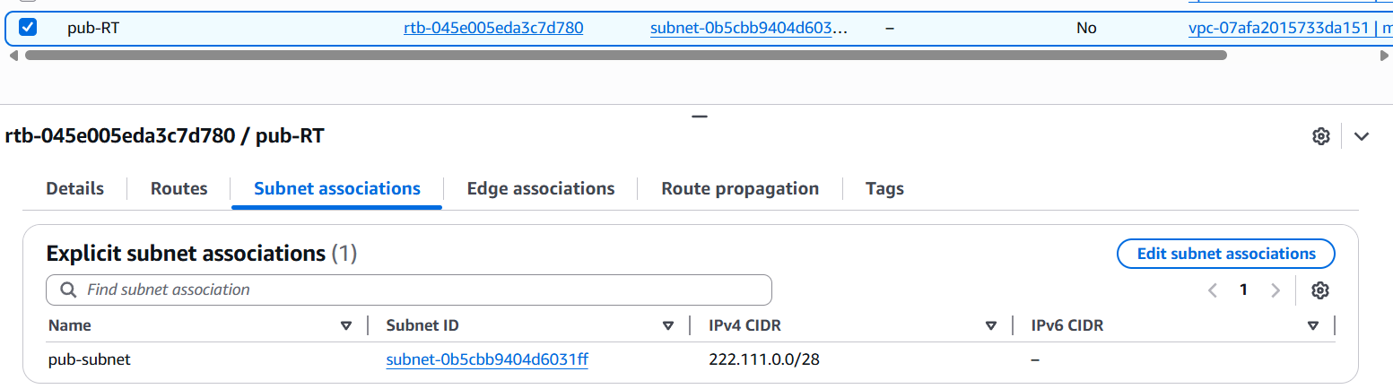
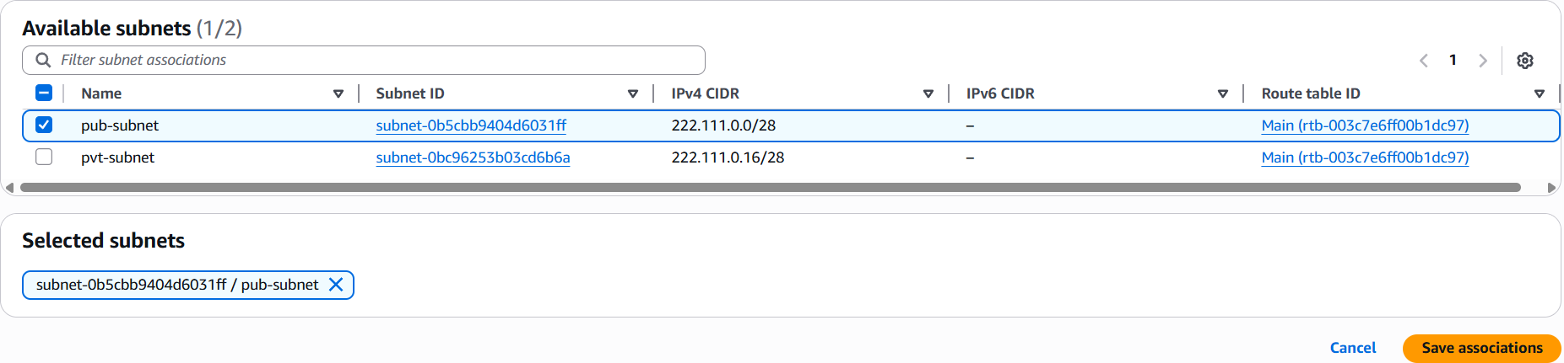
Step 7:Select RoutesEdit routes->Add routesSelect Internet Gatewaysave changes.
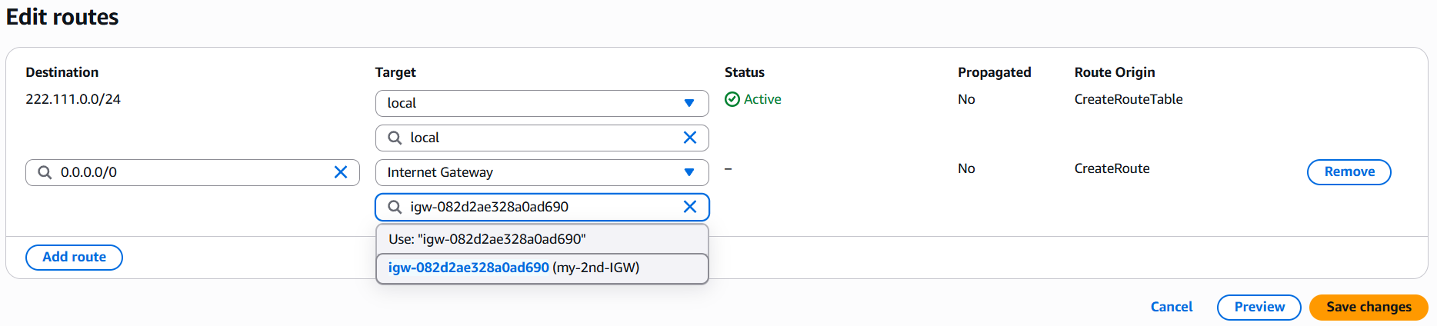
Step 8: Repeat step 5 and 6 to create private route table.
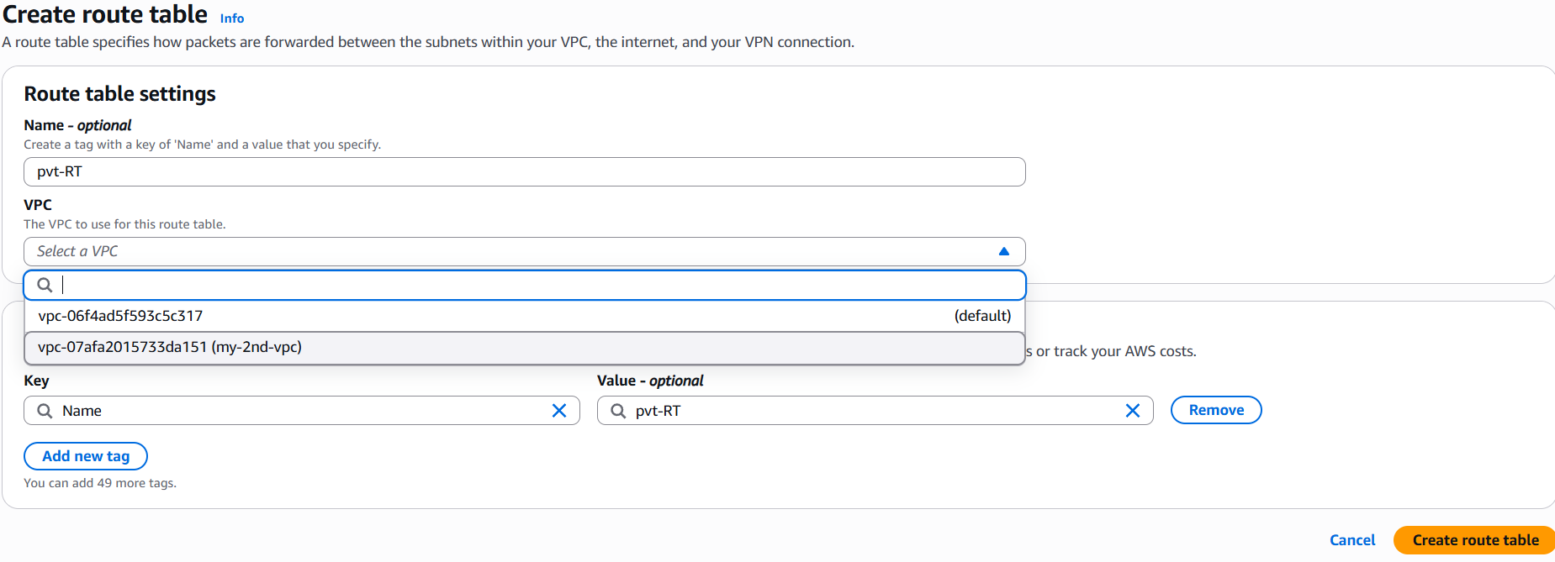
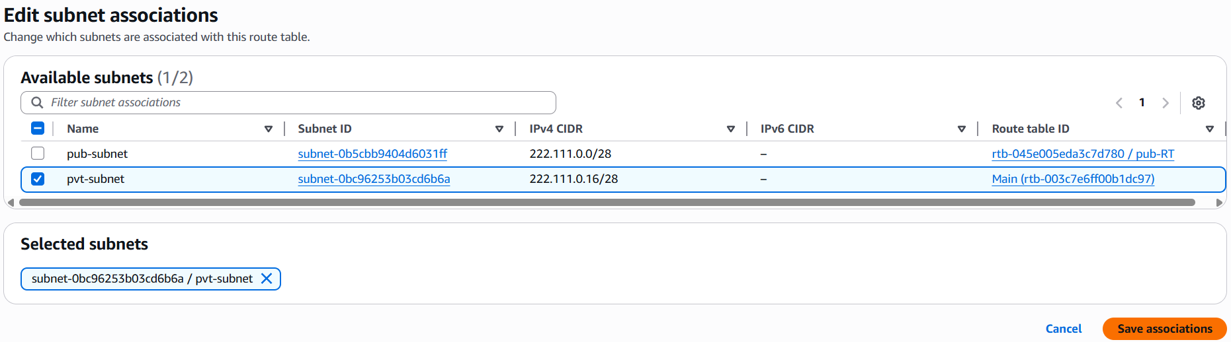
- Enable VPC peering for cross-region.
Step 1: Create 2 instances in 2 different region.
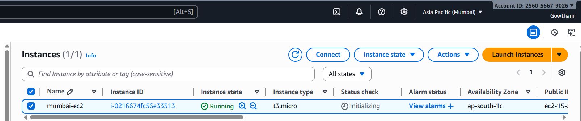
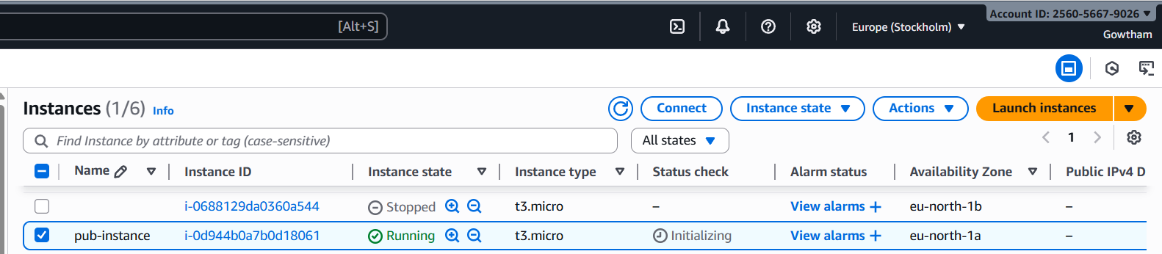

Step 2: Goto VPCPeering connectionscreate peering connectionProvide detailscreate PC
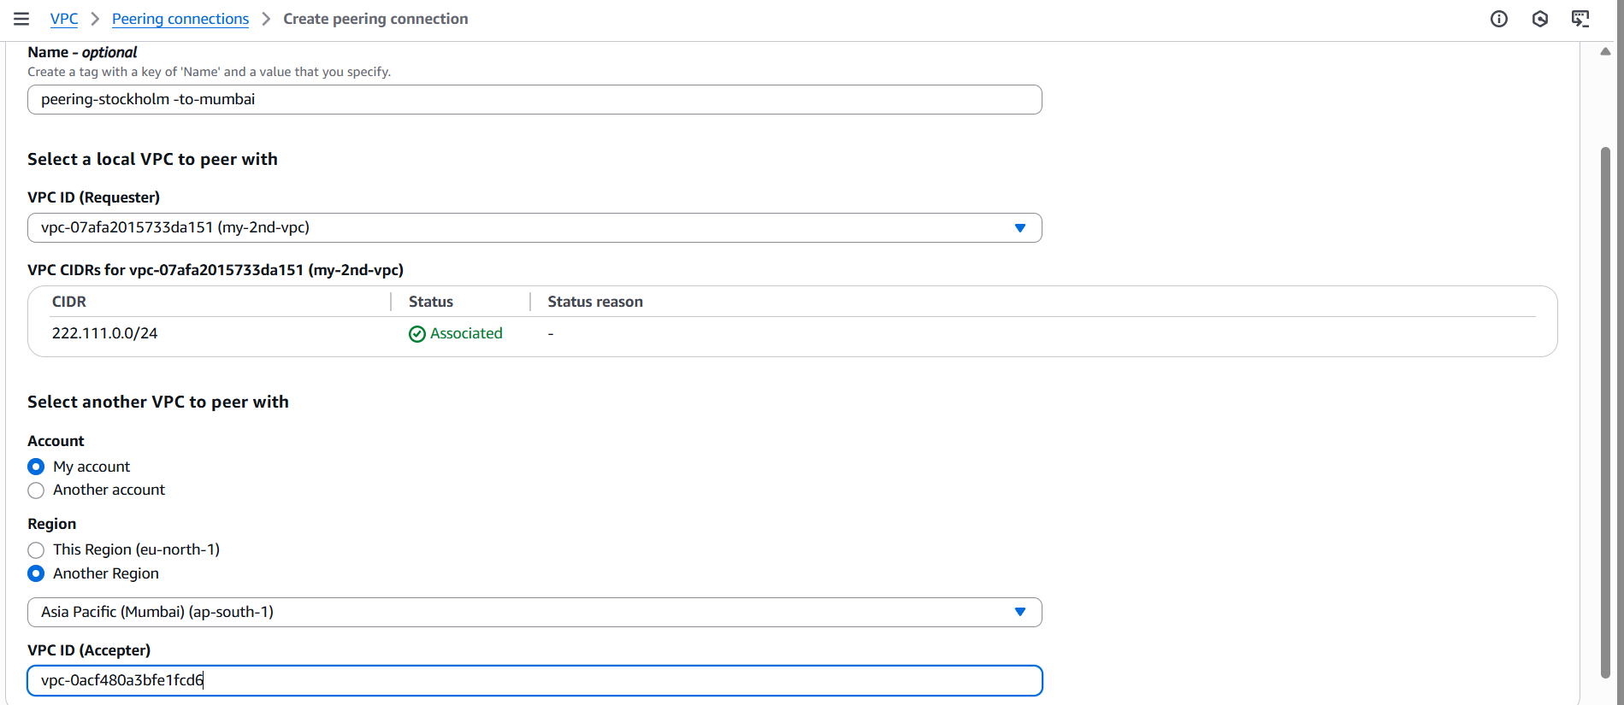
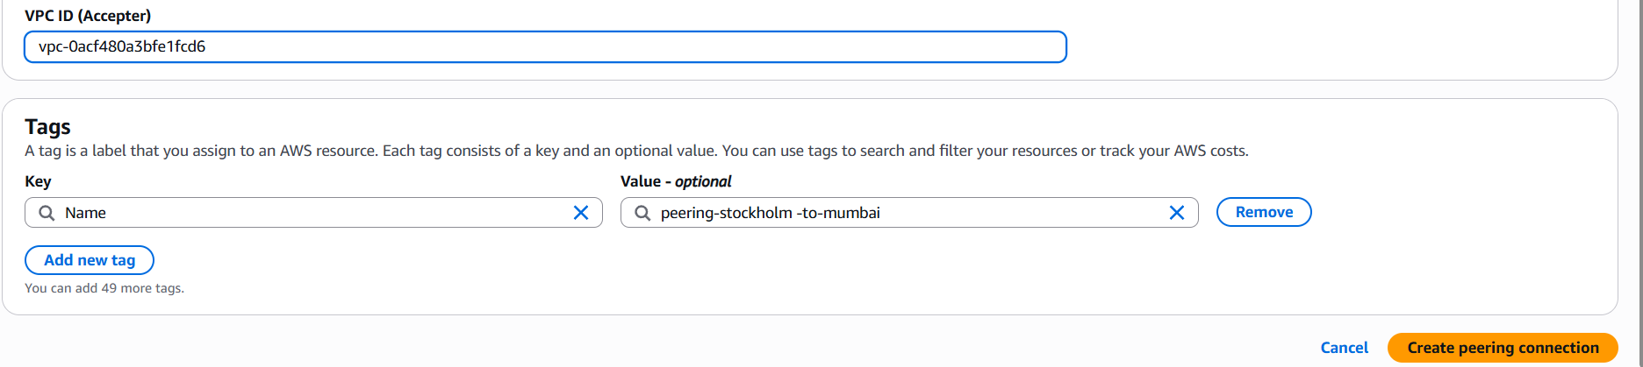
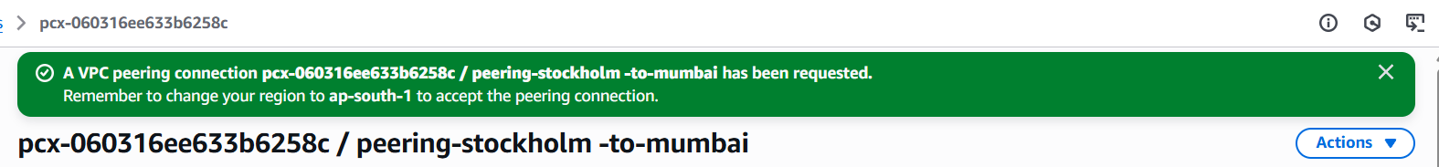
Step 3: Accept peering request in other region and modify route table in both region.
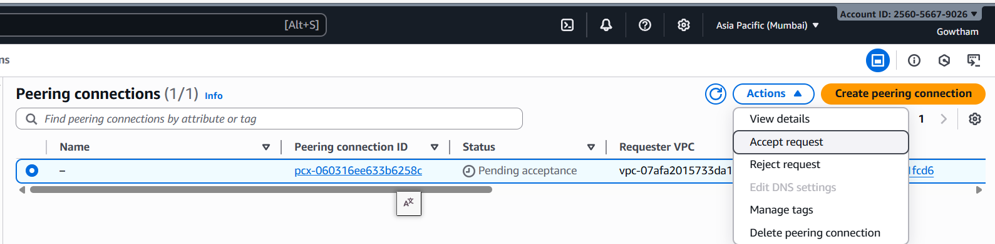
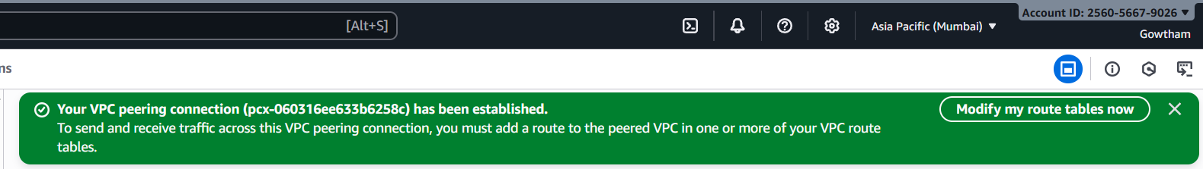
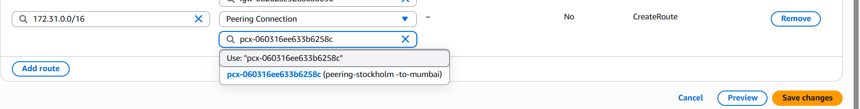
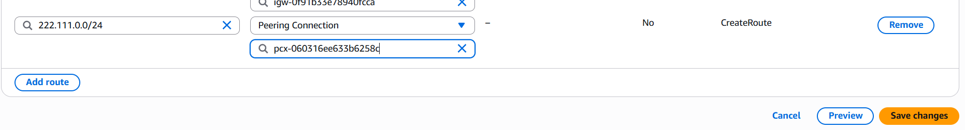
Step 4: ping private ip of other ec2 from home ec2.
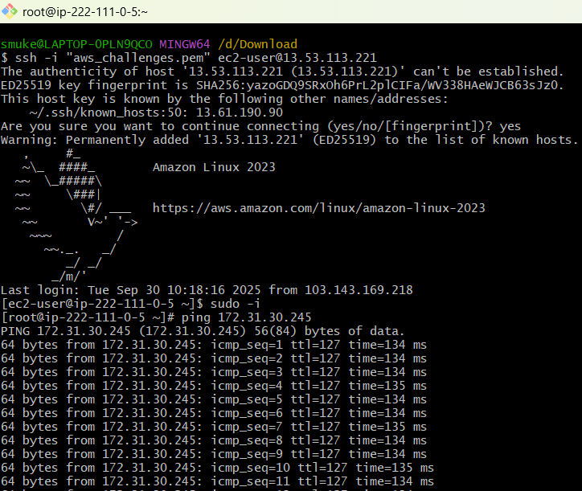

- Enable VPC peering for cross-account.
Step 1: Goto VPCPeering connectionscreate peering connectionProvide detailscreate PC
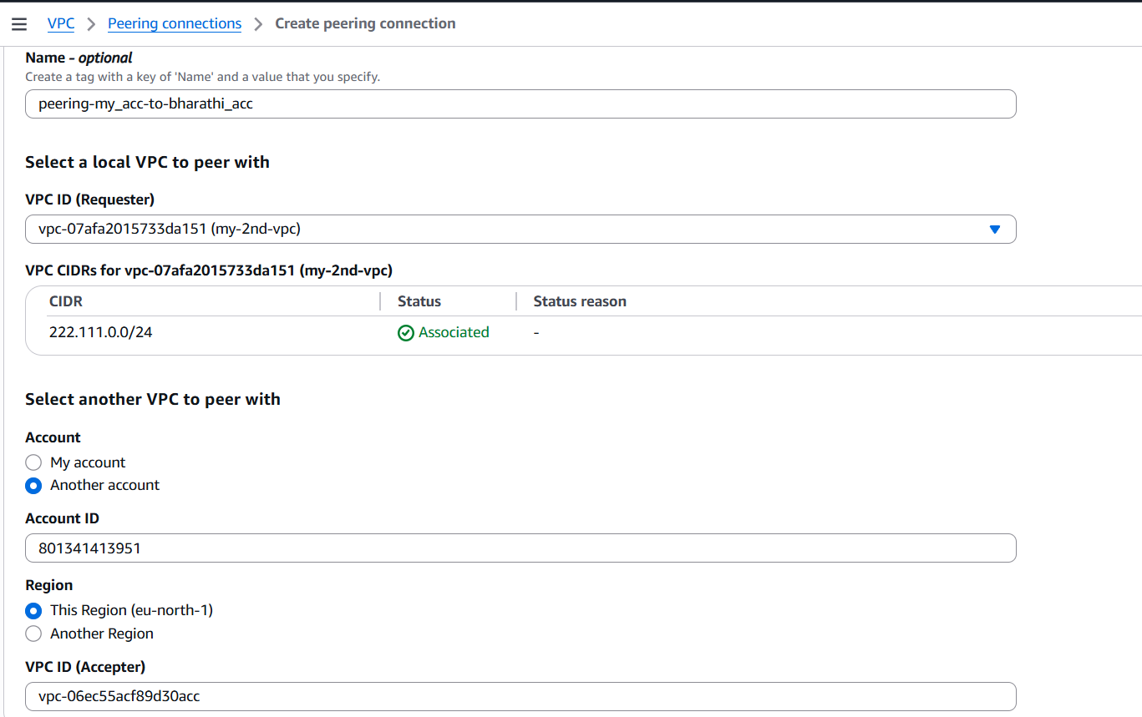
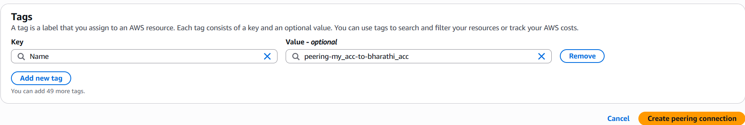
Step 2:Accept the peering request in other account and edit route table in both accounts.
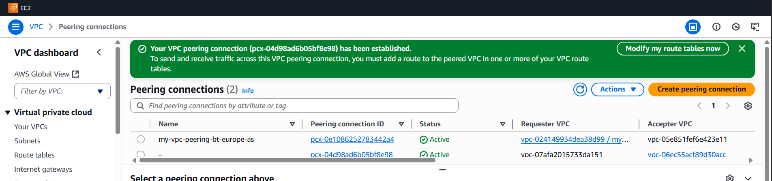

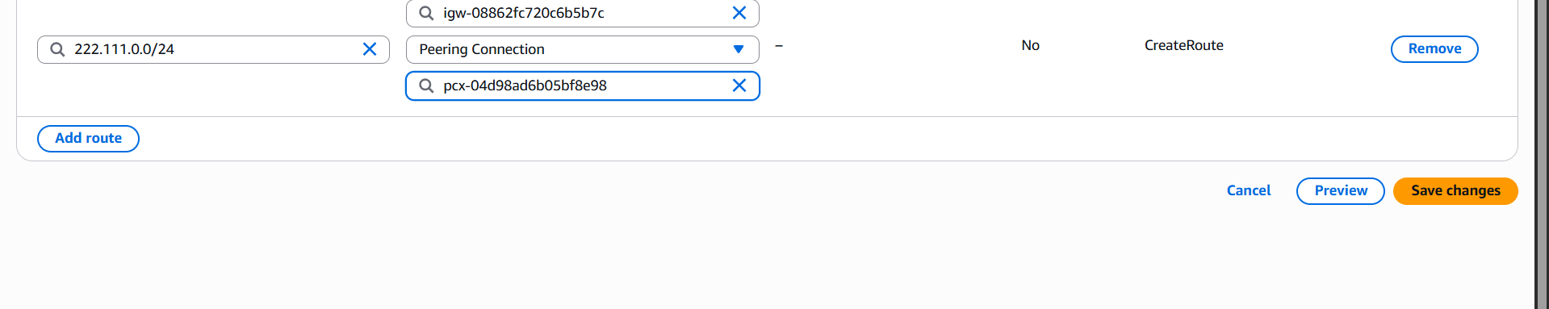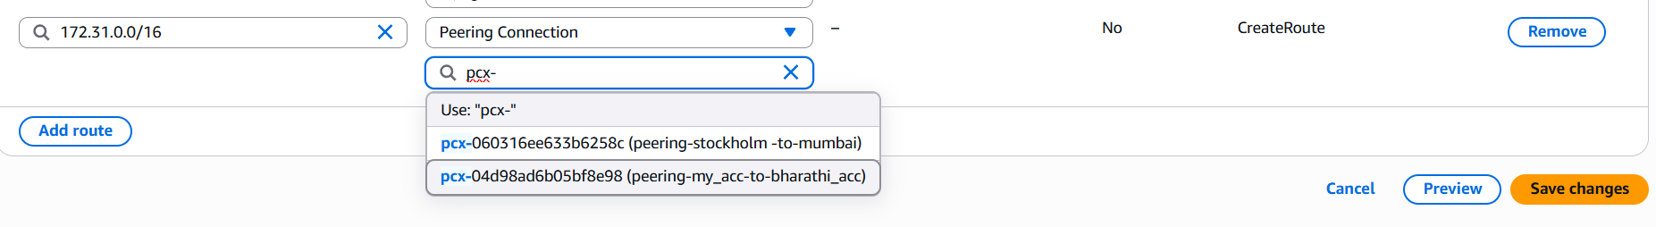
Step 3: ping private ip of other account ec2 from home account ec2.
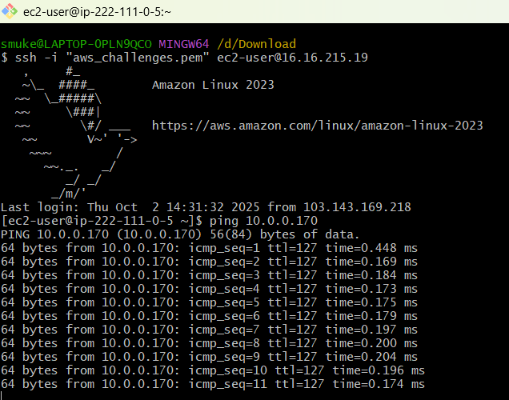

- Set up a VPC Endpoint.
Step 1: Create a VPC with public and private subnet and Launch 2 instances in private and public subnet and create a S3 bucket.
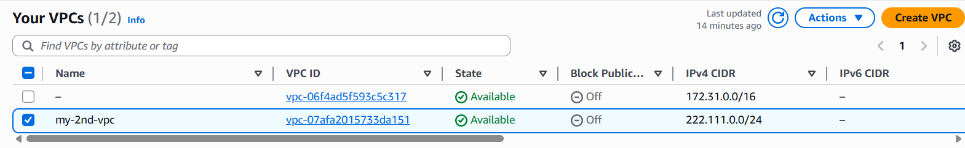
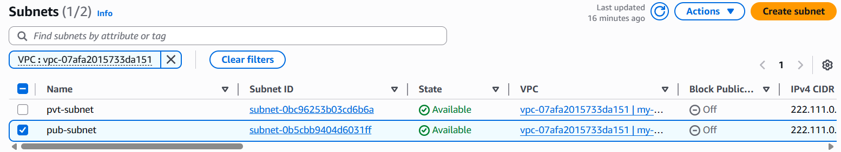
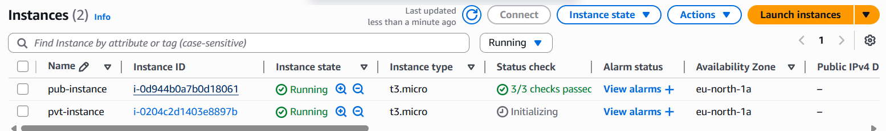
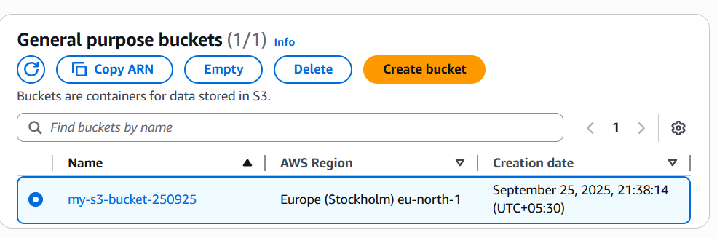
Step 2: Goto VPCEndpointsProvide detailsCreate Endpoint.
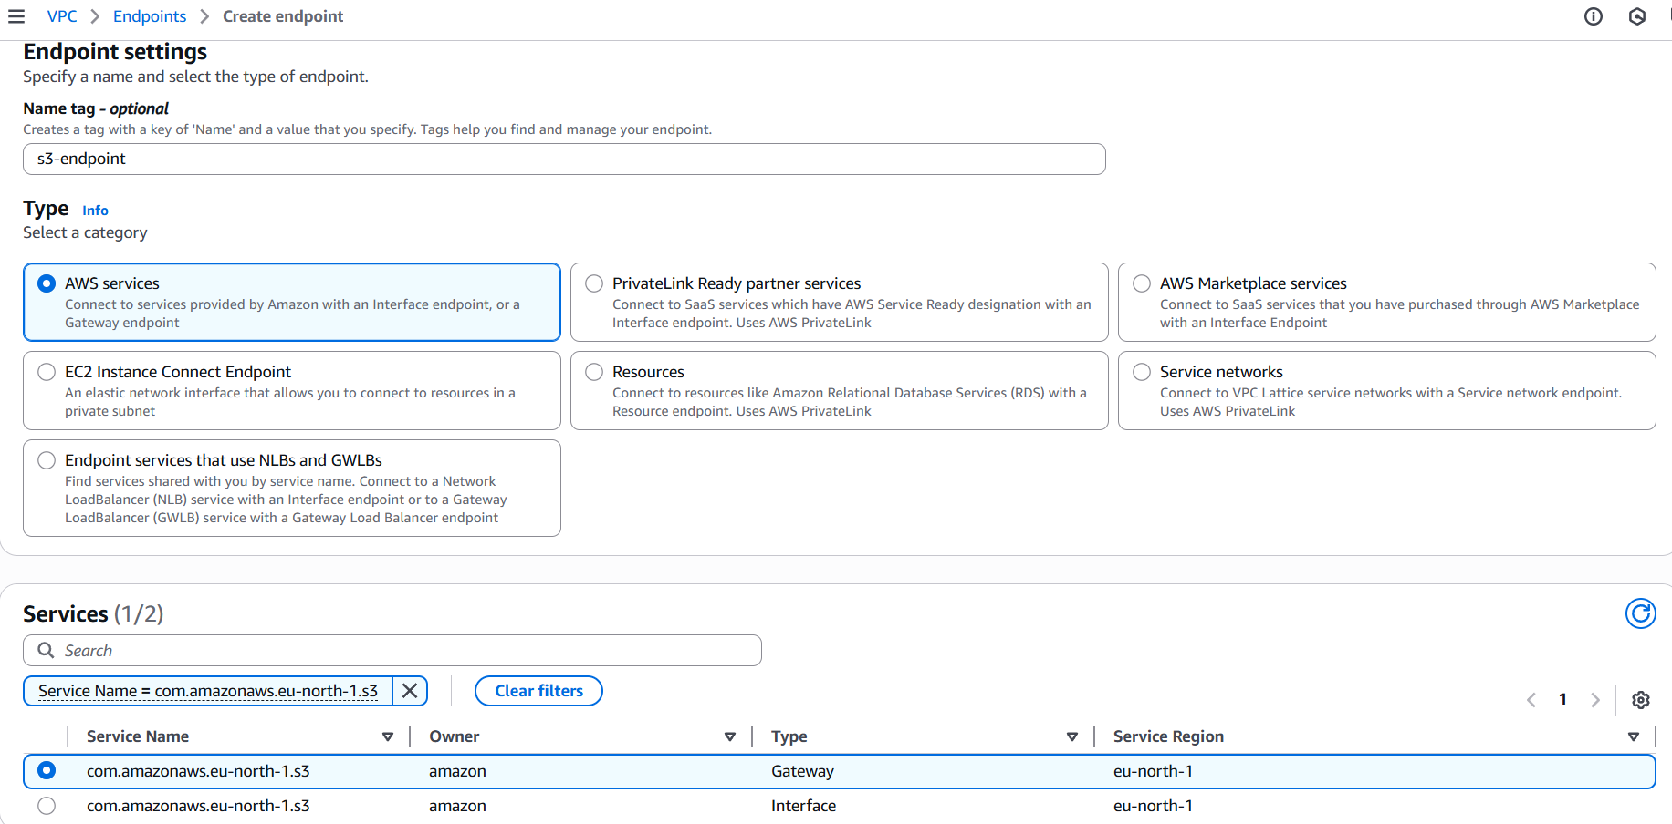
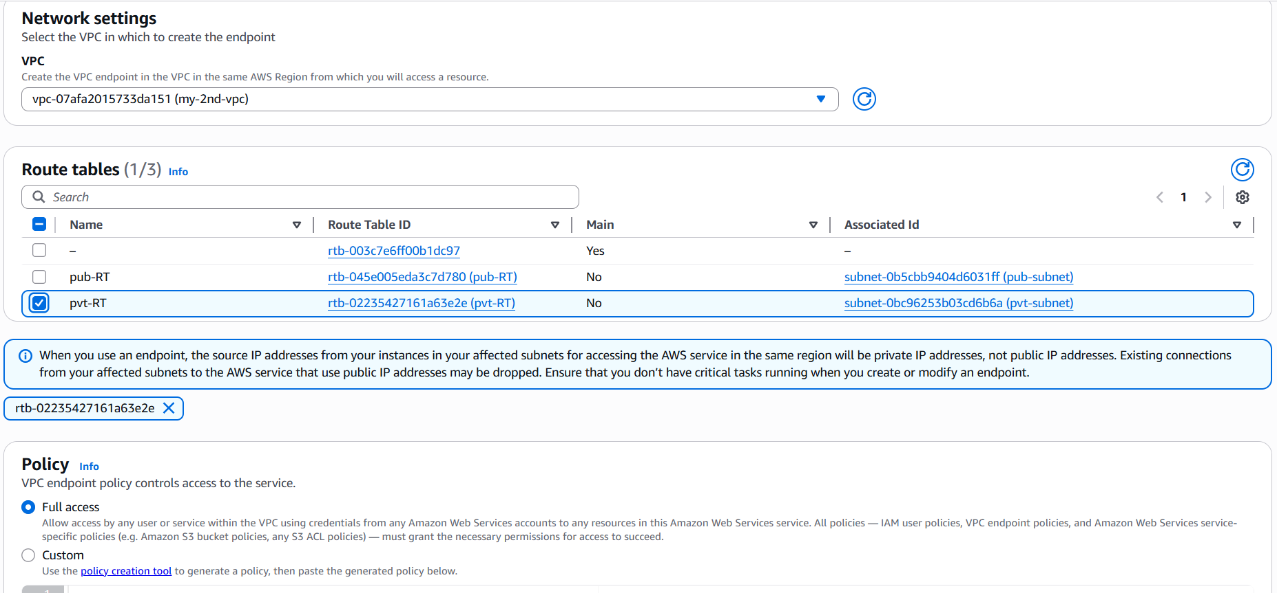
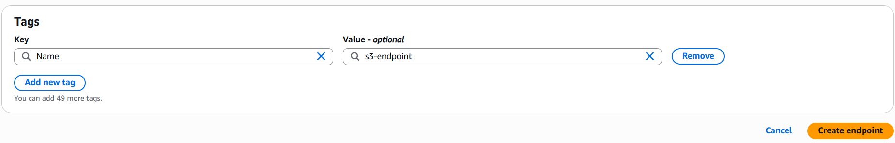
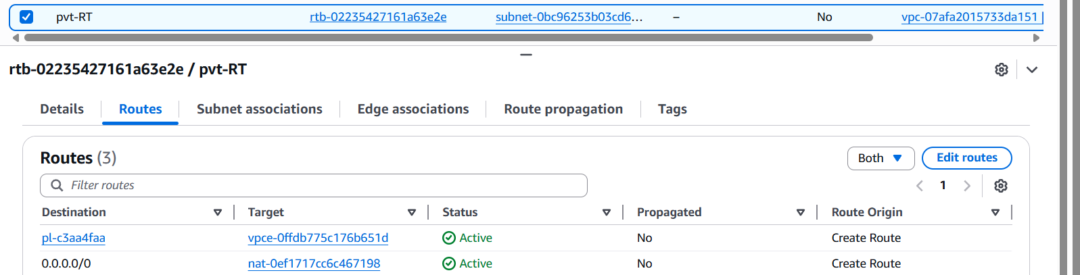

Step 3: Configure and list aws s3 bucket in both public and private instance
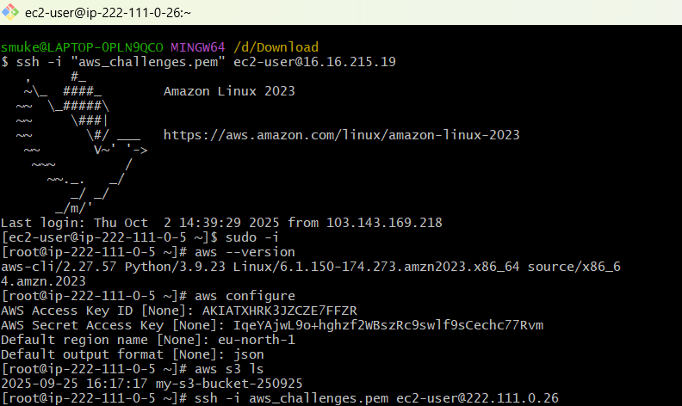
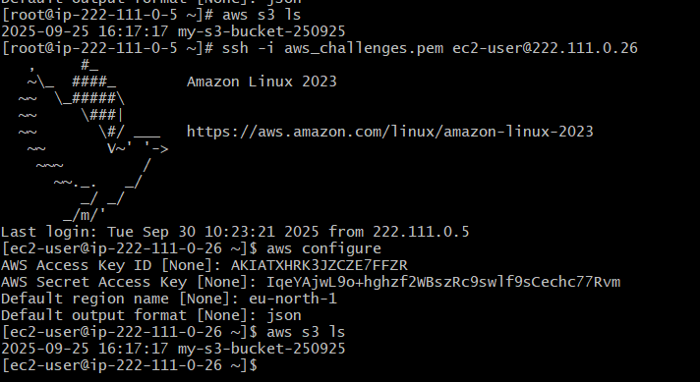

- Set up a VPC Transit Gateway.
Step 1: Create 4 VPCs with different CIDR, create 4 subnets, create 4 IGW and attach to VPC.
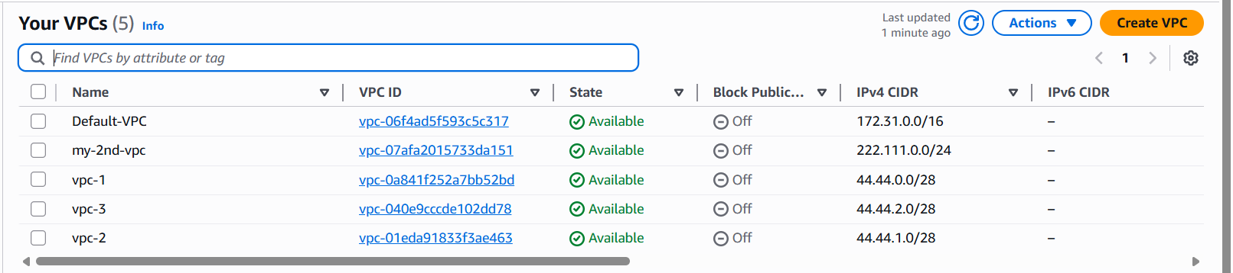
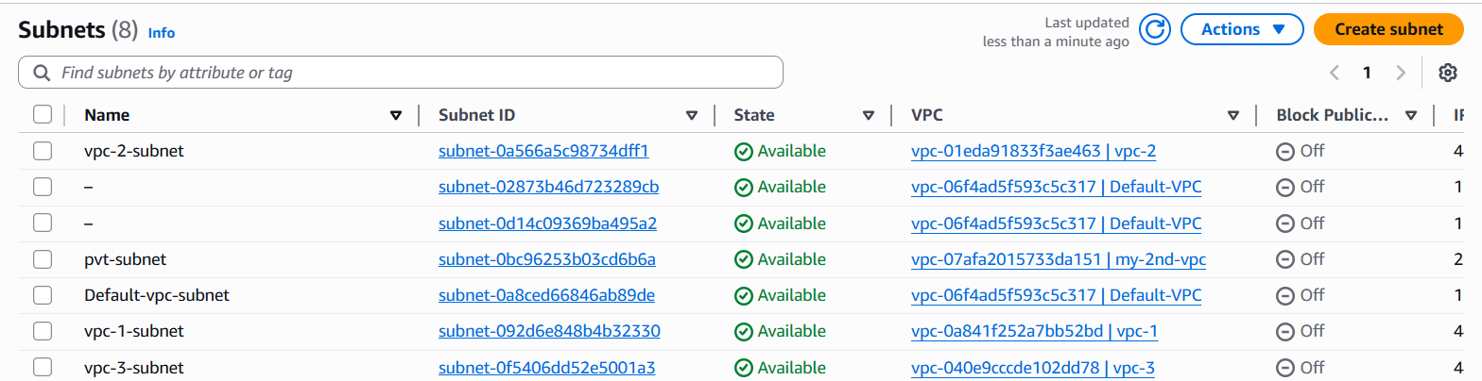
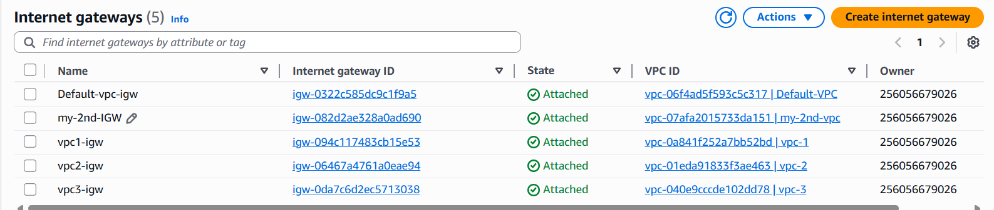
Step 2: Goto VPC and create Transit gateway and add Transit gateway attachements.
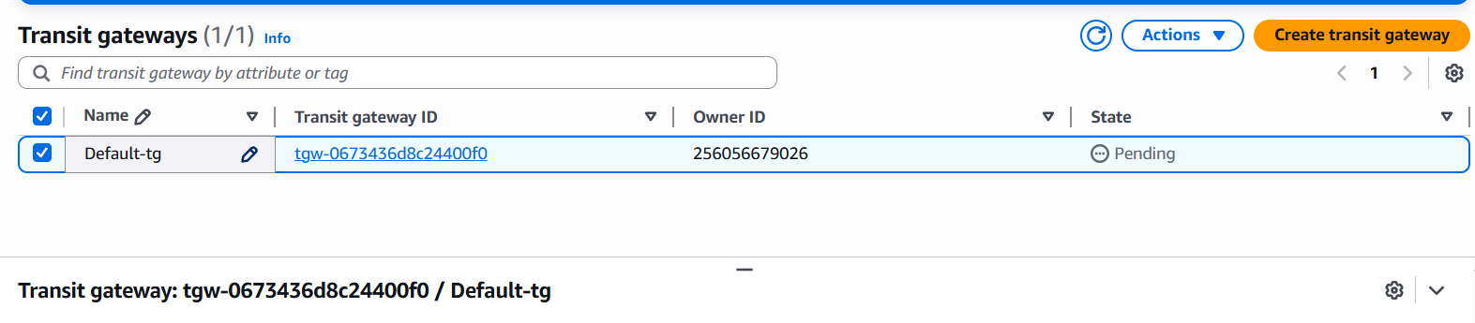
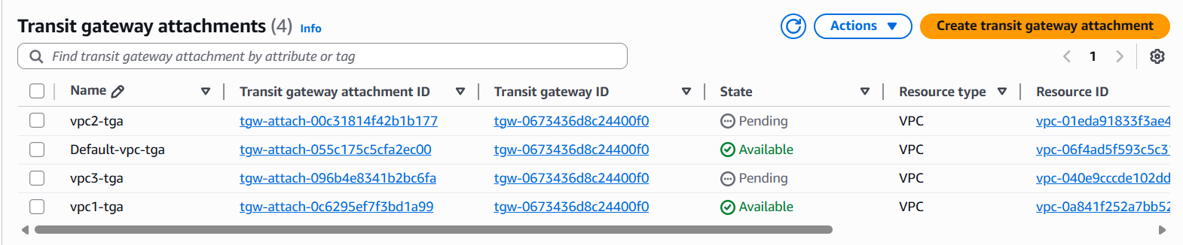
Step 3: Configure all 4 VPCs CIDR in Route of all 4 Route table.
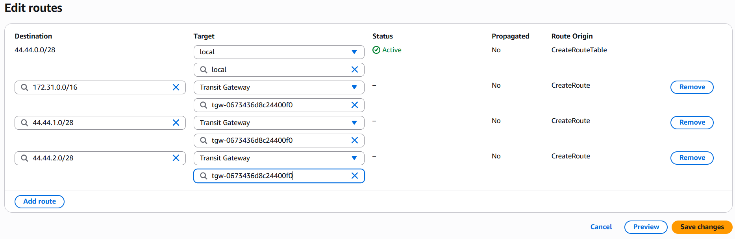
Step 4: Create 4 EC2 instances for 4 VPCs and allow all traffic in security group.
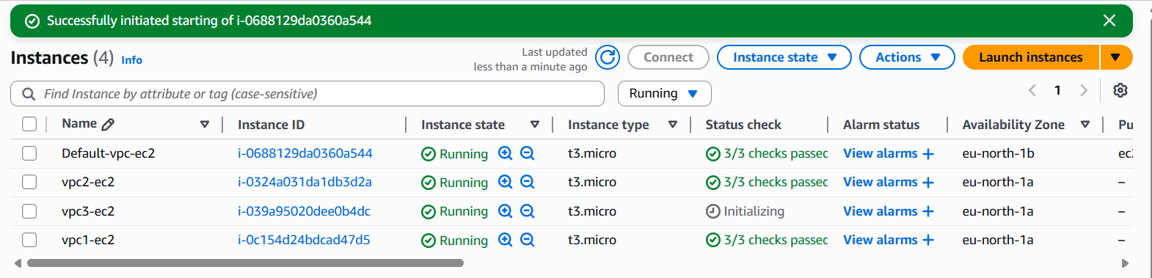
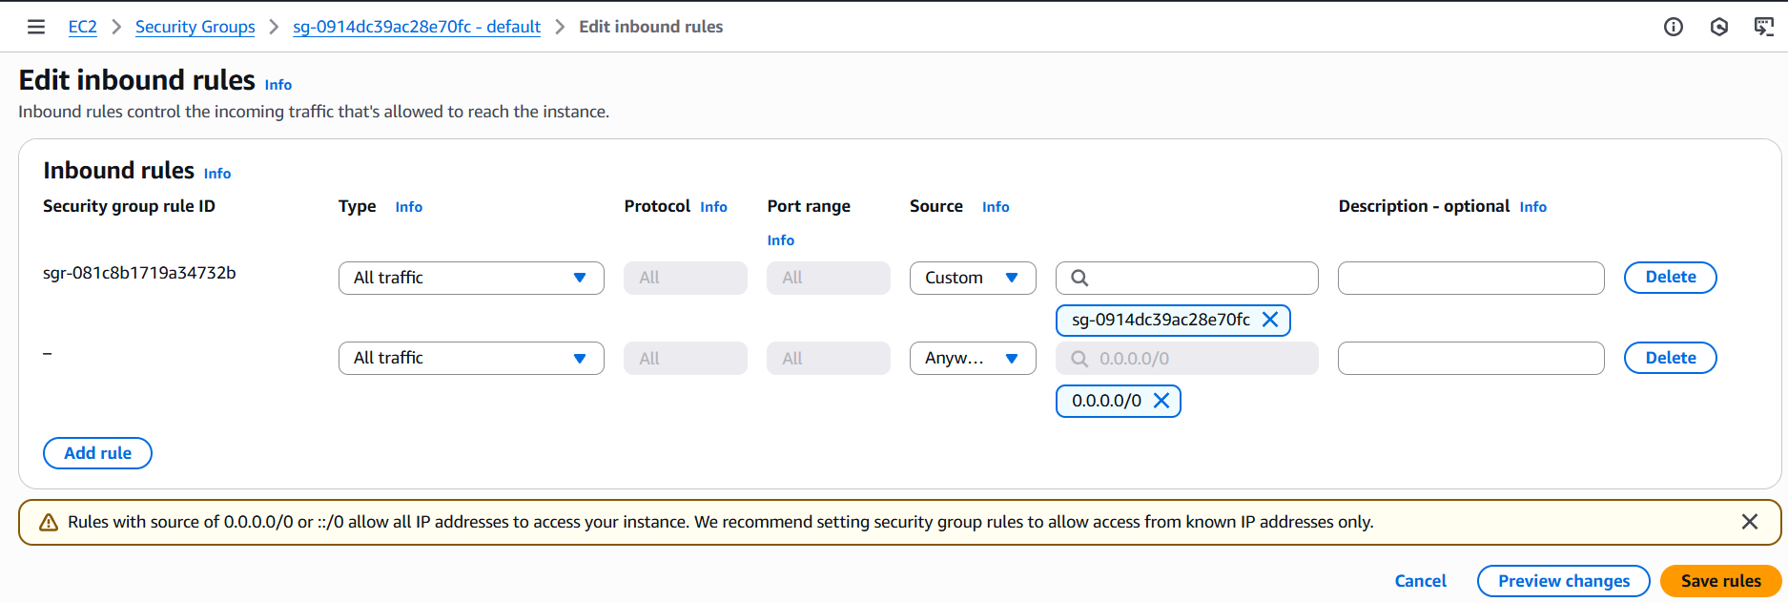
Step 5: Login to 1 ec2 instance and check remote connectivity of other instance using its private ip
